

**ELECTENG 734 - Power Electronics**

**Design Report Assessment Instructions – 2024**

# Deliverables

The following is taken directly from the Project Specifications Document available on Canvas:

*A team report, worth 25%, detailing the preliminary design, must be submitted strictly adhering to the report templates. The templates are provided to guide you through the design of your pick-up regulator and the DC-DC converter. You are expected to work on the report as a team, but must share the work evenly. Both team members must fully understand all aspects of the design as well as the design decisions/compromises that you have made. Your design report must include,*

1. *A cover page with a declaration of originality*
2. *Completed Excel design calculation sheets for both the pick-up regulator and the DC-DC converter*
3. *Formula sheets showing all equations (referenced to equation numbers indicated in the Excel sheets) used for pick-up regulator and the DC-DC converter design calculations*
4. *Detailed Altium schematic diagrams of your proposed pick-up regulator and DC-DC converter (including over voltage protection circuit) designs indicating appropriate component values and part numbers*

*You must combine the above documents into a single PDF file and electronically submit it via Canvas. The technical accuracy of your design calculations and the viability of the proposed solutions will be assessed to allocate your report marks.*

# Overview

The objective of this design report is assist you in the design of your DC-DC converter, IPT pick‑up regulator, and demonstrate your understanding of the design equations derived from the lecture material.

There are 3 main documents for both the DC-DC converter and the IPT pick-up regulator, and a component list provided to you for this assessment:

## DC-DC Converter

1. The design Excel spreadsheet "EE734_Buck_Design_Template_24_UPI.xlsx"
2. The design equation Word doc "EE734_Buck_Equations_Template_24_UPI.docx"
3. The example design Excel spreadsheet in PDF format "EE734_Buck_Design_Example_24"

## IPT Pick-up Regulator

1. The design Excel spreadsheet "EE734_IPT_Design_Report_24_UPI.xlsx"
2. The design equation Word doc "EE734_IPT_Equation_Template_24_UPI.docx"
3. The example design Excel spreadsheet in PDF format "EE734_IPT_Design_Example_24"

## General Design Documents

1. An Excel spreadsheet which lists the Power MOSFETs and Power Diodes available for use in your design report “Component List 2024.xlsx”

All submitted documents should have both team members UPI at the end of each file name.

# General Instructions for Design Spreadsheets and Equation Word Docs

You are expected to work through the design spreadsheets for both the DC-DC converter and IPT pickup and fill in the blank cells in each sub-sheet to complete the design. For example, Fig. 1 below shows the first sheet of the design Excel spreadsheet for the DC-DC converter and a blank cell with an equation number (1) next to it. You are expected to derive and enter an equation here that uses the provided specifications and load conditions to work out the output power of the buck converter when *R*L = 2 ohms. Eq (1) should then be entered into the Word doc "EE734_Buck_Equations_Template_-24_UPI.docx" using the equation editor function.

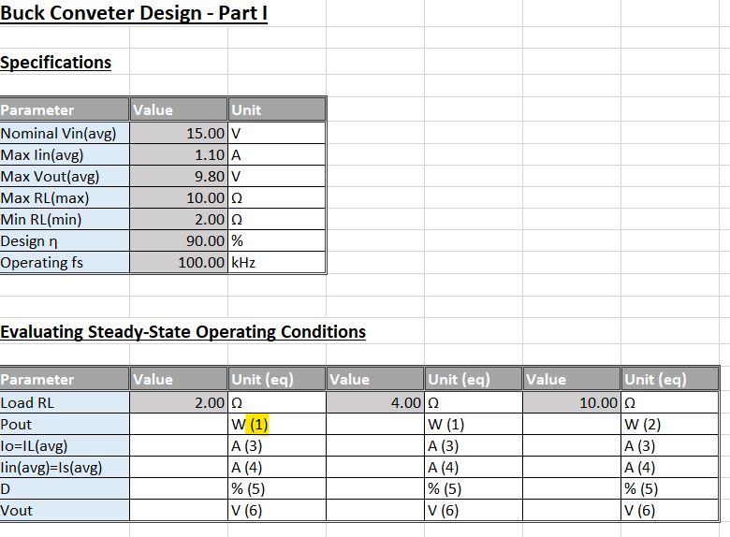

Fig. 1. Sheet 1 of buck converter Excel spreadsheet showing blank cells requiring equations to be entered.

You are also provided with a completed design spreadsheet in a PDF format "EE734_Buck_Design_-Example_24" which uses the same design process and equations you are expected to derive, but uses different specifications so the end values are different. It is highly recommended you create a copy of your design spreadsheet, edit the specifications to match those in the example PDF, and check your values match. If they don’t match, it is likely you have made a mistake in your design equation.

Note that as you move past the “Operating Conditions” sheet there are some blank cells you are expected to fill out with values obtained by completing previous sheets, such as the maximum peak inductor current, or the inductor rms current and current ripple for each of the loads. See Fig. 2 below. Also note there are blank cells you are expected to fill in with appropriate values obtained from datasheets. An example is shown below in Fig. 3.

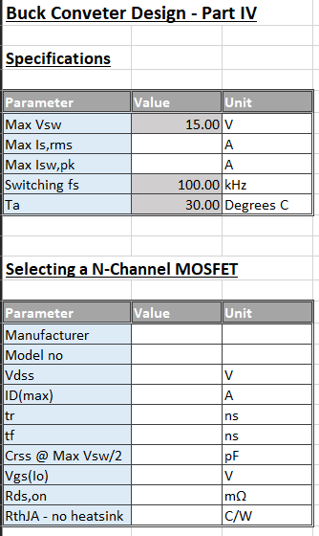

Fig. 3. Sheet 4 of buck converter Excel spreadsheet showing blank cells requiring component characteristics to be entered

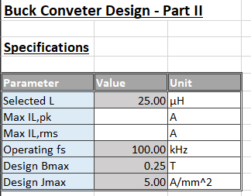

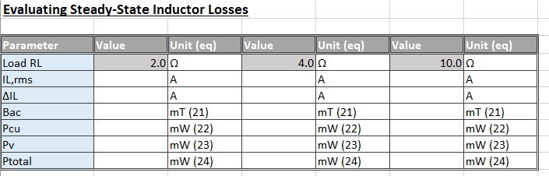

Fig. 2. Sheet 2 of buck converter Excel spreadsheet showing blank cells requiring results from previous equations to be entered.

# General Instructions for Altium Schematic

As stated in the deliverables for this assessment, a detailed Altium schematic diagram of your proposed pick-up regulator and DC-DC converter (including over voltage protection circuit) designs indicating appropriate component values and part numbers must be submitted.

The files needed for the Altium schematic are found in a zip file labelled:” Student Versions 2024.zip”

1. A PCB project for the buck converter can be found in the folder buck_2009
2. A PCB project for the IPT pick-up controller can be found in the folder regulator pcb_2009
3. The ECE pcb library is also included.

Fill in all values that your converter and controller need to function properly. Include details on the component such as diodes, MOSFETs, and capacitors where appropriate.

Do not modify the PCB layout. Any additional circuitry that desired will be implemented on Veroboard.

In the final submission, only the updated schematic files should be included

# Frequently Asked Questions

1. *Can I modify the values in the cells with a grey background?*
   1. No, these are pre-set to project specifications or values suitable for assessment purposes.
2. *Can I use any components I want? I found this really nice MOSFET or diode I would like to use?*
   1. No, for this assessment you may only choose components from the spreadsheet “Component List 2024.xlsx” which is available on Canvas. In your final design you may use a component not on this list subject to staff approval.
3. *Do I need to show working for each of the three MOSFET or diode types available in my final report submission?*
   1. No, only submit with the MOSFET or diode sheet filled out with the device you think best suits your design. However, we highly recommend you duplicate the MOSFET and diode sheet so there is a worked copy for each of the three device models available. This way you may compare between the devices and make an informed decision about which you might like to use in your final design. Either delete or hide the sheets that you don’t want to use.
4. *Any final tips?*
   1. Make sure you have gone through the checklist of deliverables for this assessment and have everything together. All submitted documents should have both team members UPI at the end of each filename.